There are two parts to my sharing today.
- Defining Saints - Our identity as Saints and the reality of being a Saint.
- Inner Healing - Do Saints need healing? What does it look like?

Defining Saints - We are all Saints.
You don’t have to be dead to be called saints. Saints, in the New Testament, were always referred to as living individuals who followed Jesus.
When Jesus died on the cross his Mercy and Grace had been placed on us, hence we are now cleansed from our sins and are made righteous - therefore we are called Saints.

The Word Saint is ágios (Hag’-ee-os) it means ‘the most holy one, sacred, physically pure, morally blameless, consecrated.So being a Saint implies that we are holy, without sin…

“Do you feel holy and without sin?” or if I can rephrase it, “Are you free from sin?”
“If we say that we have no sin, we are deceiving ourselves and the truth is not in us. If we confess our sins, He is faithful and righteous to forgive us our sins and to cleanse us from all unrighteousness. (1 John 1:8-9 NASB)

My little children, I am writing these things to you so that you may not sin. But if anyone does sin, we have an advocate with the Father, Jesus Christ the righteous. (1 John 2:1 ESV)

“IF” implies we will or are susceptible to sinning.

We are all Saints battling sin
Sin is spiritual and it is the internal battle in your mind against temptation or against self image, against the lies that the devil is planting in your head about yourself, your friend, your boss, your child, your parents etc.
These are all in contradiction to the greatest commandment - “You shall love the Lord your God with all your heart and with all your soul and with all your mind. 38 This is the great and first commandment. 39 And a second is like it: You shall love your neighbor as yourself. (Matthew 22:37-38 ESV)

Our theme verse is found in Ephesians 4:11-12
“And he gave the apostles, the prophets, the evangelists, the shepherds and teachers, to equip the saints for the work of ministry, for building up the body of Christ…”
The purpose of the Saints is to do the work of the ministry and to build up the body of Christ.

How?
We are all imperfect, we all fall short to the glory of Christ!
To build up the body of Christ is to transform our house into a home - It ought to be done with God and your neighbours who are also given the same task.

The key is to get from feeling like a sinner, feeling inadequate or unqualified to embracing this calling as a Saint and fulfilling the purpose of His destiny in our lives.

It is all about our identity and what you choose to believe.
2 Corinthians 5:17-18 “Therefore if anyone is in Christ, he is a new creature; the old things passed away; behold, new things have come. 18 Now all these things are from God…” (ESV)
“to put off your old self, which belongs to your former manner of life and is corrupt through deceitful desires, and to be renewed in the spirit of your minds, 24 and to put on the new self, created after the likeness of God in true righteousness and holiness.” (Ephesians 4: 22-24 ESV)

So we are both ‘New’ and ‘in the process’.
Our propensity to sin = Free will and the Capacity to believe in the lies of the devil.
The devil wants to attack your identity.

“The fight against our ongoing sinning is the evidence that we are in Christ”
- John Piper

If your calling is to be a minister, then don’t you want to:
- Be confident when you do it?
- Be the best version of yourself so you won’t be a hypocrite?
- Be able to do it with joy?

“Don't become so well-adjusted to your culture that you fit into it without even thinking. Instead, fix your attention on God. You'll be changed from the inside out. Readily recognize what he wants from you, and quickly respond to it. Unlike the culture around you, always dragging you down to its level of immaturity, God brings the best out of you, develops well-formed maturity in you.” - Romans 12:2 MSG

Our life on earth is temporal, don’t let it eat into you so deeply that you become numb to the need for healing.

- Inner healing is for everyone.
- It is a way of processing with the Lord.
- Inner healing is where you meet God face to face.
Intimacy with Christ ought to be the foundation of our relationship and if you feel unsatisfied with your relationship with Jesus then you need to meet Him face to face and let Him draw out the deep things within your heart.

Mary had a very tender heart towards Jesus because he met her face to face. He delivered her and healed her.
She was the chosen one to proclaim the news of the Risen King.
- Is your heart tender towards Jesus?
- Do the things that break his heart break yours?

Knowing Him gives meaning to these works (reading the bible, praying, serving, sharing, leading). Knowing God gives meaning to our routine, He breathes life into our dead works.

Inner Healing - Do Saints need healing? What does it look like?
When Jesus came to save the world. He also healed it.
The Greek word for salvation is Sozo with its root meaning beyond just the forgiveness of sins, it also means to save, to deliver, to protect, to heal, to preserve and make whole.

The physical and the spiritual world
How do we look on the inside without healing? I think it looks something like this…
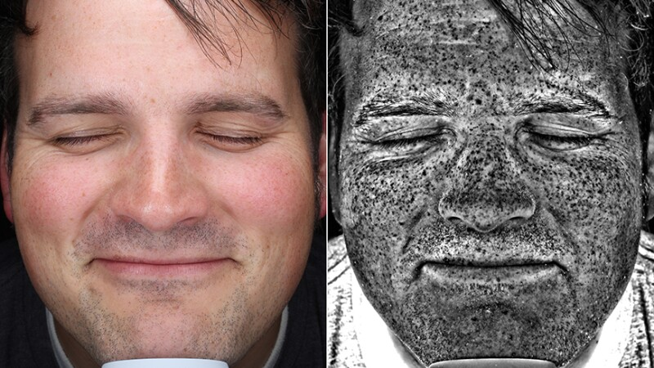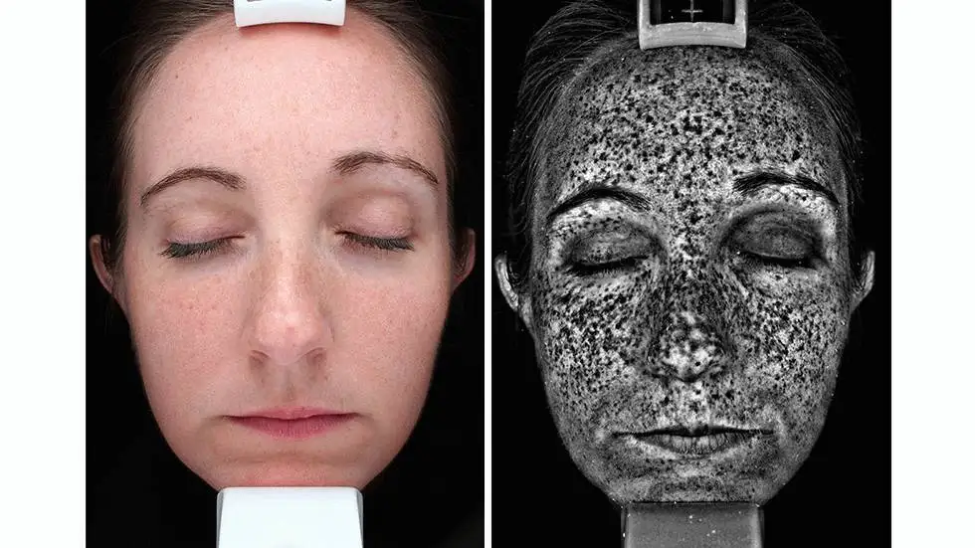

When it (the hurt etc.) have time to fester and grow it manifests into something like
- broken relationships,
- depression, panic attacks,
- suicidal attempts,
- gambling,
- Pornography,
- lying,
- fruitlessness,
- addiction,
- bitterness…
(Non exhaustive list)

Typical Process of destruction
- Childhood hurt/ neglect (0-7 years)
- Lie enters in through learned response (i.e. neglect) or incidences (i.e. divorce)
- Lie iInternalised and forms view point in life
- Life happens - accumulate more negative experiences
- Manifestation

The lies sound like this:
- "I can never do anything right!"
- "I don't deserve to be happy!"
- "I'll fail anyways”
- “The world is better without me”
- “What am I doing here!”
- “I am so scared”
- “I am unworthy”
- “I’m a horrible ____”
- “I hate my dad”
- “I will never forgive _____”
- “How could I do that!”
- “Nobody understands me”
- …

Psalm 46:1
“God is our refuge and strength, a very present help in trouble.”
- A few weeks ago my son went to A&E
- One year ago I was in a car accident with my son.
- My miscarriage

Processing with God.
- On your own
- With other mature believers
- River ministry

When do you need River sessions?
- When you feel stuck. There has been no breakthrough and the cycle has been repeating itself.
- When you are in bondage - pornography, gambling, gaming etc.
- Irrational Fear
- Uncontrollable emotions like anger, rage, swearing
- Unforgiveness and bitterness
- Panic attacks, depression, anxiety
- Suicidal attempts or thoughts
- Not wanting to be around people
- Traumas and hurts
- Broken relationships.
- etc.

