Secrets of a Fruitful Heart PART ONE
Mark 4:2-20 bobsorge.com

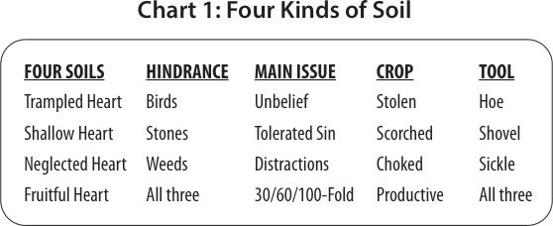

We want to be more fruitful because the Lamb deserves the reward of His sufferings.

The parable’s imagery:
Sower = Jesus
Seed = Word of God
Soil = Hearts of the hearers
Psa. 92:14 They shall still bear fruit in old age; they shall be fresh and flourishing.

Spiritual fruit: Any godly deposit or quality that makes it into the age to come. (John 15:16, “that your fruit should remain”)
Some examples of spiritual fruit:
- Friendship with Jesus
- Christlike character (Gal 5:22)
- Edifying the body of Christ
- Winning souls (Prov 11:30)
- Wise financial stewardship (Luke 16:9).
- Obedience to Jesus
- Providing for your household.
- Raising children in the fear and instruction of the Lord
- Enduring persecution for Christ’s name (Matt 5:12)
- Glorifying God (John 15:8)
“If you abide in Me, and My words abide in you, you will ask what you desire, and it shall be done for you. By this My Father is glorified, that you bear much fruit; so you will be My disciples.” (John 15:7-8)

To glorify God is to cause people’s esteem of Him to elevate.

“that we should bear fruit to God” (Rom 7:4).
Why are not all believers 100-fold fruitful? Three hindrances: Birds, stones, and thorns.

There’s spiritual warfare every time the word is spread. In Luke 8:5, the seed was also trampled.
“Break up your fallow ground” (Jer 4:3).
“Sow for yourselves righteousness; reap in mercy; break up your fallow ground, for it is time to seek the LORD, till He comes and rains righteousness on you” (Hos 10:12).

Foot traffic that can trample our hearts
- People traffic
- Animal traffic
- Carts/Systems
“But if you bite and devour one another, beware lest you be consumed by one another!” (Gal. 5:15)
“If your brother sins against you, rebuke him; and if he repents, forgive him” (Luke 17:3)
How can we soften our heart?
- Repent, Isa 66:2
- Weep, Matt 5:4
- Forgive
- Fast
- Pray the Scriptures
- Erect traffic guardrails
- We need rain, Zech 10:1; Hos 6:3

People can trample your heart, but they can’t soften it.

Secrets of a Fruitful Heart PART TWO
Mark 4:2-20
Stones hinder root development.

The sun’s heat represents trouble, persecution, temptation (Luke 8:13). Stones: Pockets of sin that hinder root development.
Hidden stones surface because of weather changes. We can be tempted to medicate our stones.
Examples of stones that can hinder our roots from going deep: Unforgiveness, anger, hatred, addictions, a bad relationship, cynicism, evil speaking, sexual sin, foolish talking, fear, lying, rebellion, coarse language.
Matt. 6:34 Therefore do not worry about tomorrow, for tomorrow will worry about its own things. Sufficient for the day is its own trouble.
Only a fearless heart can be hundredfold fruitful.

1Tim. 4:8, “For bodily exercise profits a little, but godliness is profitable for all things, having promise of the life that now is and of that which is to come.”

Thorns represent neglect:
“I went by the field of the lazy man, and by the vineyard of the man devoid of understanding; and there it was, all overgrown with thorns; its surface was covered with nettles.” Prov 24:30-31

Five things about weeds:
- Every garden gets them.
- Weeds dominate.
The fruitful is choked by the fruitless.
- They take a lot of hard work to suppress.
- They always come back.
- Weeds have a positive purpose in the right place.

Three kinds of weeds:
- The cares of this world, Mark 4:19
“cares” Literally means, “to divide the mind”
- The deceitfulness of riches, Mark 4:19
- Desires for other things, Mark 4:19 (“pleasures of life” Luke 8:14) Money is useful in life when it’s kept in a peripheral place in our hearts. Cut back the weeds of money with generosity and almsgiving, Luke 11:41 What does the pillar of salt represent?
Prov. 4:23 Keep your heart with all diligence, for out of it spring the issues of life.

